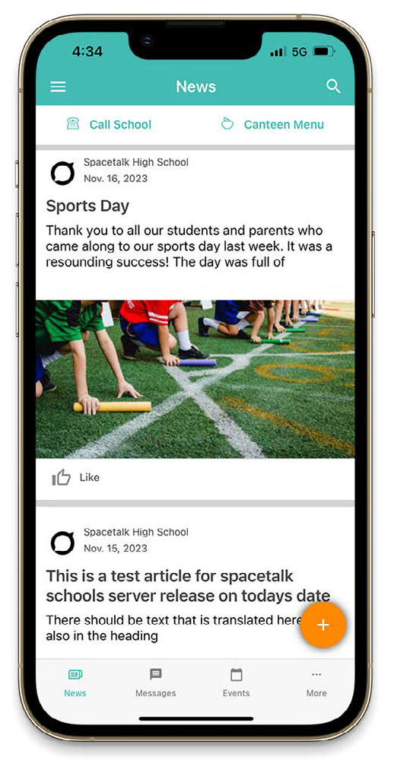
School fundraiser
What a wonderful day at the school fundraiser. We’d like to say a huge thank you to all who participated.

GET READY FOR THE SCHOOL YEAR WITH THE NEW
Spacetalk Schools App
The Spacetalk Schools App allows you to access up-to-date information about the school and your child.
The app has recently been updated to make it easier to use, plus it’s received some enhancements that make login, registration, news and notifications more reliable.
Features include:

- View the school news feed.
- Receive messages from the school.
- View the school events calendar.

1.

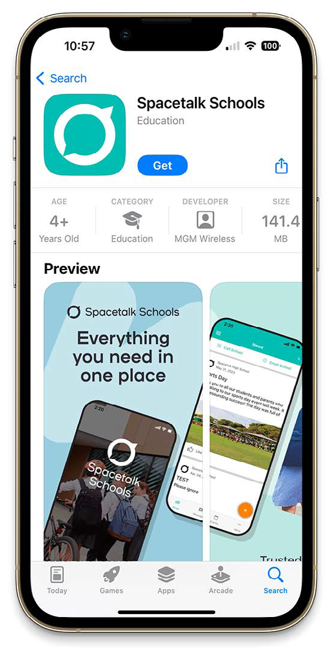

Getting Started
Step 1: Download
Download the Spacetalk Schools App for either iOS or Android.

Or scan the QR code.

2.

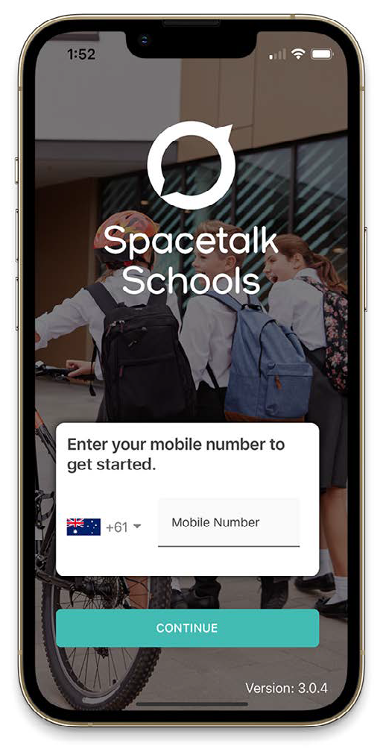

Getting Started
Step 2: Enter your mobile number, then login or register
Launch the app and make sure you enable notifications when prompted. Enter your mobile number and you’ll be shown the schools associated with your account. Select the schools and tap continue.

If you have previously used the app:
Enter your login details. If you’ve forgotten your password, tap the ‘Reset your password here’ link.

If you’re new to the app:
Tap ‘Register for a new account’, complete your details then hit continue. You will then get sent a 6-digit code via SMS to confirm your account.
Once your mobile number is verified tap ‘finish’ and you’ll be logged into the app.

3.

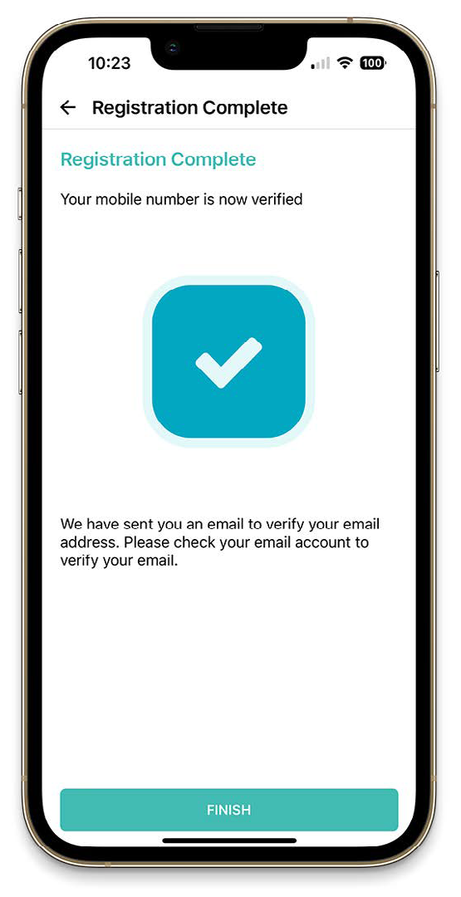

Getting Started
Step 3: Verify and register
A verification email will also be sent to the address you used to setup your account. Please verify your email address by clicking the link supplied. This enables you to receive all notifications.

Please note your personal details may be used by the school for SMS, password recovery and email communications throughout the year.

4.

